

Master of Education in Learning
Design and Technology

Learning Analytics (Spring 2026) sec. 01

EDLD 607

Assessment 2

Proposal

(Data-Informed Learning Intervention)

Submitted To
Dr. Hasan Kettaneh

Done by: Hanadi Khaled
Student ID: 200117276

25. March. 2026

Learning Situation and Problem.

The proposal is placed in an online learning platform that is facilitated by Learning Management System (LMS) in which a group of 25 students participate in coursework, exams, and group discussions. Those learners show different degrees of fit and academic achievements.

The major issue highlighted is poor engagement of learners that is closely linked to poor performance and high chances of failure. The students who have made fewer than 20 LMS logins, less than 3 hours a week of activity, and low quiz scores are disproportionately represented in the at-risk group. This is a important concern because it directly affects the learning outcomes, progress, and retention.

Learner Data to Be Used

The proposal would work with the data that we had used in Assignment 1, engagement (logins to LMS, time, contribution to forums), performance indicators (quiz averages, assignment marks, and final course status), and ultimate course position.

The individual learner is the unit of analysis. Some of the key indicators are the frequency of logins, time-on-task per week, engagement with forums and evaluation performance.

Although the dataset offers good behavioral information, it lacks demographic and motivational variables that could be interpreted causally.

AI-Enhanced learning analytics and techniques.

Patterns of engagement will be detected using descriptive analytics. Diagnostic analytics will investigate correlation of engagement and performance.

Thresholds (less than 20 logins, less than 3 hours/week, quiz less than 60 percent) will be used to identify at-risk students in predictive analytics. Targeted interventions will be launched by prescriptive analytics.

Tools developed with AI will be used to generate feedback and alerts, and their use will be controlled by a teacher.

Design of Learning Interventions.

The intervention is a combination of Early Warning System and Personalized Support.

Triggers:

LMS logins < 20

Weekly time < 3 hours

Quiz average < 60%

Actions:

Automated alerts

Instructor support

Personalized study plans

Forum engagement prompts

The proposed intervention is operational, based on learning theory and analytics.

Evaluation Plan

Success indicators will be measured with the help of SMART:

Increase in LMS logins (>30)

Growth in time spent ( >5 hours/week)

Improvement in quiz scores (>70%)

Evaluation involves pre/ post comparison and constant monitoring.

Responsible and Ethical Design.

Privacy, transparency, fairness and human oversight are also ethical safeguards. The use of data will be made known to the students, and no interventions will be stigmatizing or biased.

Visual Logic Model

The Portland Airport data-to-decision pathway is given below:
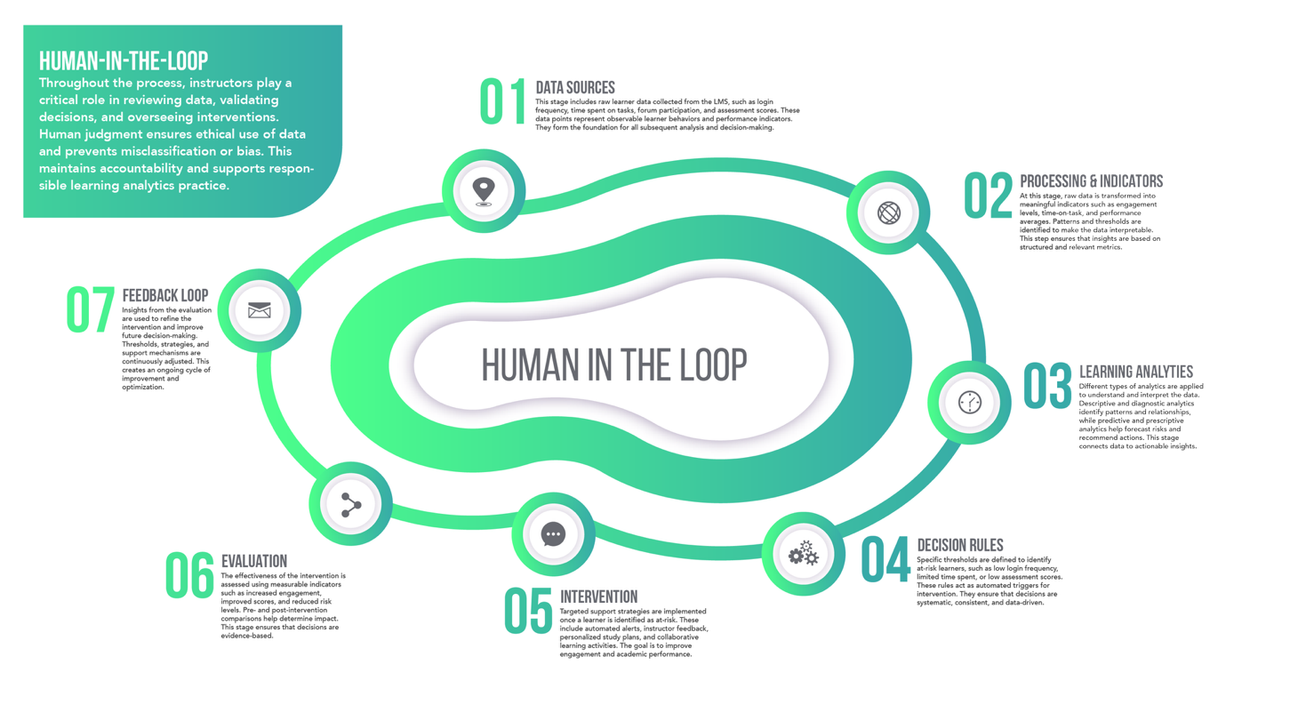

Conclusion

This plan provides an evidence-based, systematic method of enhancing the student neuromotor and cognitive experience and outcomes using specific and ethical interventions.

References
Gašević, D., Dawson, S., & Siemens, G. (2015). Let’s not forget: Learning analytics are about learning. TechTrends, 59(1), 64–71.
Siemens, G., & Baker, R. (2012). Learning analytics and educational data mining: Towards communication and collaboration. Proceedings of LAK.
Slade, S., & Prinsloo, P. (2013). Learning analytics: Ethical issues and dilemmas. American Behavioral Scientist, 57(10), 1510–1529.

